**Final Report**

**Authors:**

Emad Bin Abid | Saman Gaziani

**About the Authors:**

Emad Bin Abid, ea02893, CS Major, C&D Minor **|** Saman Gaziani, sg02494, CS Major, Mathematics Minor

**Project Idea:**

*Electronic Voting System.*

**About the Project:**

Electronic Voting System is an idea which replaces manual voting system by using digital circuits. The system a two candidate voting environment which allows the voters to vote for their favorite candidate just by pressing a single push switch.

**Abstract (Reference: Project Proposal):**

Manual voting procedure now seems to lose its significance as advancement in technology has given rise to electronic voting i.e. the voting circuit comprising of logic gates and logic signals. It has variety of advantages including security of votes, validity of votes and keeping a check on counts. Moreover, it is convenient for people as it reduces the margin of human error.

**Components Used:**

Following is a list of all the components used in project.

|  |  |  |
| --- | --- | --- |
| **Serial No.** | **Item** | **Quantity** |
| 1. | 4 bit Counter (IC: 74LS93) | 4 |
| 2. | Binary – to – BCD Converter/BCD Driver (IC: 74HC47) | 4 |
| 3. | Seven segment Display (Common Anode) | 4 |
| 4. | 4 bit Comparator (IC: 74LS85) | 1 |
| 5. | Push switches/CLK (Voter switches) | 2 |
| 6. | Slide switch | 1 |
| 7. | 330k Ω/ 3.3k Ω Resistors | 30 |

**Functionality/Working:**

The system comes into its operating mode when a slide switch is active. In its active mode, the switch gives access to the voter switches by sending them a HIGH signal on their accepting pins. Now the voter is allowed to vote for his favorite candidate. To avoid repetition in explanation of functionality, the function of first candidate system will be discussed only. The system of second candidate is the exact replica of the later one.

The voter switch is directly connected to the counter. The four output pins of counter are then connected to the corresponding pins on BCD driver. The seven output pins of BCD driver are connected with seven pins on the display. The system is firstly set to all clear state i.e. the display in its initial mode shows the value 0.

The initial state of the system’s individual components is:

Code on 74LS93 output pins: DCBA → 0000

Code on 74HC47 output pins: abcdefg → 0000001

Value on seven segment display: 0

When the voter presses the voter switch, a HIGH command is passed to the counter IC (74LS93). Since the counters are mostly edge-sensitive circuits, it adds one to the current sequence on receiving a leading edge from voter switch. The current state of system’s individual components is:

Code on 74LS93 output pins: DCBA → 0001

Code on 74HC47 output pins: abcdefg → 1001111

Value on seven segment display: 1

Similarly after pressing the voter switch nine times, the state of system’s individual components is:

Code on 74LS93 output pins: DCBA → 1001

Code on 74HC47 output pins: abcdefg → 0000100

Value on seven segment display: 9

On the next press being a 4 bit (modulus 16) counter, technically the value on display should become 10 but this system displays 0 again after displaying 9 (decade counter). The functionality is not limited to 9 votes only, in fact, the pins D and B are connected as the clock of another counter via an AND gate – 7408 (cascaded). This AND gate produces a HIGH output only when both D and B are high. This means that the other counter circuit only transitions whenever it receives 1010 i.e. the code of 10. In this way two counter circuits are cascaded to increase the count of votes from 0 - 9 to 0 - 99.

The second candidate system works the same way as above. At the end, a comparator keeps a track whether candidate A or B is winning or if both are on a tie.

**Block Diagram:**

For the sake of clear and explicit image, the block diagram has been divided into two parts.

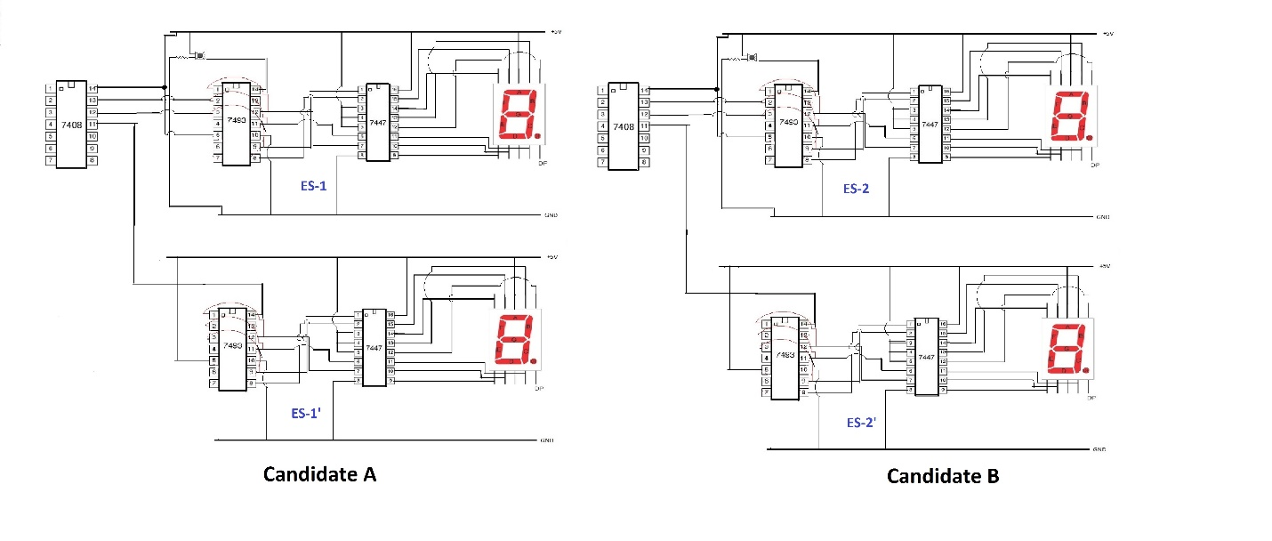

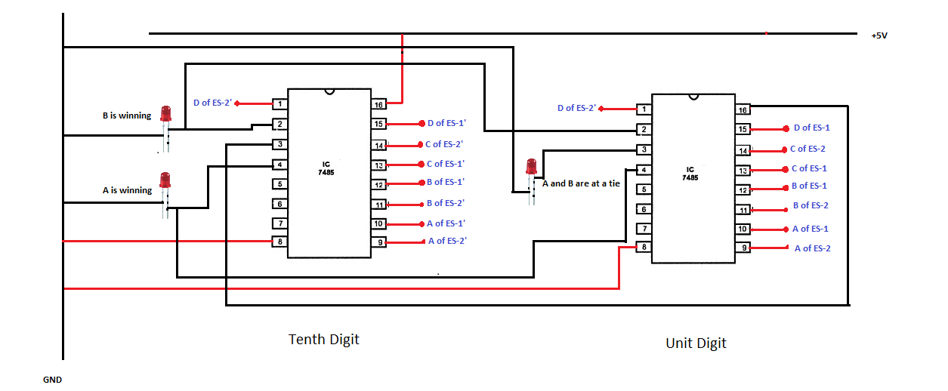

**Design Issues Faced:**

The very first design issue faced was that the team wanted to save the cost by directly connecting output pins of counter to the seven segment display. This was a major design lapse. While implementing the hardware, the team was able to fix this bug because the display could not have been connected in any way directly with 74LS93 as the display had seven pins (one for each segment) and 74LS93 was providing only four. Thus the need of BCD driver. Secondly, since there are two kinds of displays; common anode and common cathode, the team used common cathode display which was not applicable in this system because the BCD driver transmits LOW state on output pins. Hence, the display was showing buggy output.

**Cost of Design:**

|  |  |  |  |  |
| --- | --- | --- | --- | --- |
| **Serial No.** | **Item** | **Cost/Item (PKR)** | **Qty.** | **Total Cost (PKR)** |
| 1. | 4 bit Counter (IC: 74LS93) | 58.00 | 4 | 232.00 |
| 2. | Binary – to – BCD Converter/BCD Driver (IC: 74HC47) | 90.00 | 4 | 360.00 |
| 3. | Seven segment Display (Common Anode) | 11.00 | 4 | 44.00 |
| 4. | 4 bit Comparator (IC: 74LS85) | 50.00 | 1 | 50.00 |
| 5. | Push switches/CLK (Voter switches) | 5.00 | 2 | 10.00 |
| 6. | Slide switch | 5.00 | 1 | 5.00 |
| 7. | 330k Ω/ 3.3k Ω Resistors | * - - - | 30 | * - - - |

*Total Cost of Project= PKR 701..00/=*

**Possible Future Amendments:**

The system our team has developed is just a prototype of a to-be big technological advancement. The team could have refined and re-pursue the system to a more real-world usage machine but the deadline of project submission did not allow the team to work more on remaining ideas. This report will now discuss some ideas which could not be implemented this time but can be implemented whenever the project goes into the streamline for further advancement.

1. The count of votes can be increased to any number just by cascading more counter circuits in a similar manner as discussed earlier in report.
2. In order to ensure that a person castes his vote once, in place of a voter switch, finger print sensor can be used which only adds the vote to the sequence if that particular finger print has not casted it before. Along with finger print sensor, registers will also be used for this design in order to retain finger impression in memory.
3. The voter input (the vote) can also be provided through computerized software mechanism by linking it to the custom-coded program.
4. Thinking of really high level application, the voter input can also be provided using face recognition system developed through AI/Machine Learning procedures.
5. The cost of system can be lowered.
6. In place of all this IC setup, a field-programmable gate array or Arduino or even micro-controllers can be used.